

Welcome
to
Kindergarten!
(An Information Guide for Parents)

Our Lady of Sorrows School
Mrs. Anna Corrado
Ms. Maria De Amaral
September 2017

Welcome to Kindergarten!

September is such an exciting month! For teachers and children, it is a month of change and new beginnings – new surroundings, new friends, new experiences, new skills, and new challenges. We are happy to be working with your child this year and we are very much looking forward to a year of making learning fun for you and your child.

The “First Day of School” is a great milestone for your child and we understand that you and your child may have met this day with excitement or apprehension (or a little of both). We hope that this booklet will help you to know what to expect in Kindergarten this year and to answer any questions you may have. Throughout this booklet we will share some of our beliefs and school/classroom policies.

We will begin by introducing you to the “Must-Have Skills” for Kindergarten success. We are sure that many of you parents have spent a portion of the summer coaching your child to learn his/her numbers and letters. As was mentioned to you at the June Orientation, it is very important that you spend time teaching your child a few key non-academic skills to help him/her make the transition to now coming to school for the full day. Skills that foster independence are the most important skills to have when entering Kindergarten. In particular, a child with strong self-help skills is more able to focus on the academics at school and thus be better prepared for Kindergarten success.

The following skills should be nurtured at home to make the transition to all-day school smoother for everyone:

- Skill #1: Getting Dressed Independently
Yes, we are available to assist your child with dressing and undressing, however it helps with time management if your child has mastered or is close to mastering this skill. Your child will deal with putting on and taking off his/her shoes, runners, sweater, or coat several times a day. Please help your child learn to dress him/herself, and ensure that he/she learns to use buttons and zippers. Velcro shoes are practical at this stage.
- Skill #2: Being Responsible for Belongings
Your child will have his/her individual full length cubby in which he/she will store all belongings. Teach your child how to hang up a coat and backpack on a hook. Make your child aware of his/her belongings and their whereabouts (i.e. snack, lunch, runners, etc.)
REMEMBER TO LABEL ALL OF YOUR CHILD’S BELONGINGS WITH A BLACK PERMANENT MARKER!!!!
- Skill #3: Bathroom Success
It is important that you practice proper bathroom hygiene steps with your child (wiping, washing hands, etc.).
Accidents happen and it’s always better to be well prepared so that it does not cause any anxiety. On the off chance that your child does not make it to the washroom, please make sure that there is always a change of clothes (school gym strip as well as undergarments and socks are a suggestion) inside his/her backpack that can be easily accessed without making a big scene.
- Skill #4: Eating Without Help
Remember there is a time limit for your child to eat his/her snack and lunch at school. Have your child practice opening the Rubbermaid containers, juice boxes, Ziploc bags, thermoses, or any other pouch container that your child may be bringing to school. This will give your child less frustration and more time to eat.
- Skill #5: Following Directions
In Kindergarten, your child will learn all about self-regulation: that is, showing less impulsivity, waiting his/her turn, and following directions. Listening and following directions gets better with practice. Please help us with this skill by instilling this at home. Playing games like “Simon Says” and “I Spy” with your child will also help develop the ability to listen, observe and follow directions.
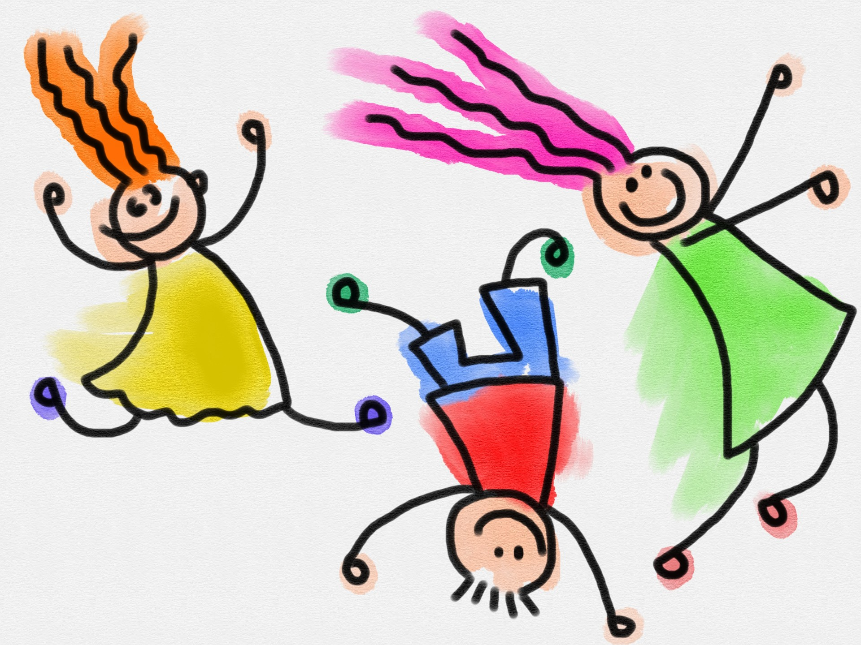

Academic Learning
Today’s Kindergarten curriculum is filled with exciting academic learning. Your child will explore the world of learning and will develop many basic skills. Our new curriculum helps students learn by exploring. You, on occasion, will be asked to help your child research and/or send to school materials for certain class projects.

Work booklets, sheets, cards etc. will be sent home on a regular basis to reinforce and help develop taught skills. Encourage your child to use these materials to practice and develop new skills at home.

Please take time to discuss each school day with your child. Ask questions and offer positive feedback. Review work and set aside a special place for displaying the work. Your expression of interest will play an important part in your child’s learning success.

Parent/Teacher Relationship
We believe that a good parent-teacher relationship is necessary for maximum school success. Throughout the year we will communicate with you as much as possible. Your child will have a Communication Folder in which we may put any notes or reminders as well as any schoolwork. This folder will go home with your child each day and is to come back to school with your child each morning. Please make it part of your daily/nightly routine to go through the folder and then place it back into your child’s school bag (ready for the next school day). This folder is also where you may send to school any notes. If ever you have any questions or concerns about school, or your child, and you feel that you cannot send us a note in the Communication Folder, then we encourage you to contact us at the school
(604) 253-2434. You can also visit our website www.ourladyofsorrows.ca, for many updates.

School Attendance
Your child’s regular and prompt attendance at school is crucial to his/her success. We can’t emphasize this point enough! If, however, your child is going to be absent (in case of illness or emergency) please call the school before the beginning of class and leave a message with the secretary. Please send a note in your child’s Communication Folder when your child returns to school with the date(s) of his/her absence and an explanation of why your child was not at school, OR you can email your absentee notice directly to the school secretary at ourladyofsorrows1@shaw.ca. This is a school policy and is collected for our records in receiving the B.C. of Education Ministry funding.

Sick Days
It is very important that you keep your child at home when he/she is sick. This is to prevent the spread of germs and illness to others.

Early Pick-Up
If your child needs to be picked up early from class, please call the office to inform the school or send a note in your child’s Communication Folder and state the time of pick up. When you arrive to pick your child up, please use the front entrance of the school and check in with the secretary. She will then inform us and we will do our very best to make sure that your child is ready to be picked up at the time requested. Please do not come directly to the classroom so as to not interrupt learning in progress.

School hours and Kindergarten Arrival and Dismissal
School begins at 8:45 am, however we ask that Kindergartners be lined up 5 minutes prior to the bell, as we will let them in early to avoid commotion. Look for the blue “K” by the school’s back door (west side – school playground), and have your child line up against that wall. Kindergartners are dismissed at the same door at 2:45 pm.

Please wait outside closer to the back of the building for your child. Each child will be dismissed as the family member, or the person that is responsible for your child’s pick up, is recognized. It is important that you do not enter the school and wait outside the Kindergarten classroom as you will block school dismissal traffic.

Note: the rest of the school is dismissed at 2:50 pm. If you are late in picking your child up, please call the school to inform us. Your child will either be waiting inside the classroom or depending on the tardiness, waiting in our Afterschool Care. Fees may be applicable if your child is to attend afterschool care.

Changes in Pick-Up
If your child is going to be picked up by someone other than the usual person, please send a written note in your child’s Communication Folder stating this.

Snack/Lunchtimes
Your child should bring a small snack as well as a full lunch to school every day. Please send healthy foods and preferably water or milk rather than juice. Your child should bring these in a lunch bag/box.

**ALERT**
Please note that our school is a PEANUT FREE school. This means that no peanut butter or any peanut products are allowed. We would appreciate your consideration for this as these products could be life threatening to some children. Please read the Warning Signs on the classroom doors and DO NOT SEND ANY FOODS CONTAINING ANY OF THESE PRODUCTS!!!!

****************

Gym/Physical Education Class
Your child will need to have an OLS gym strip at school every day. He/she will not be changing into a gym strip until January. However, we ask that you keep this in a Ziploc bag in your child’s school bag to be used as a change of clothing in case of accidents. As well, your child will need to have a pair of runners (for gym class) kept at school in his/her cubby that will remain here for the course of the year.
*******Please label all of your child’s belongings*******

Music
Your child’s Music Teacher is Mr. Mark Pepe. Kindergarten has a structured music lesson every Monday and Friday. Music class is held in our Music Room, which is across the hall from our classroom and library.

Library
The school Librarian is Mrs. Bond. Kindergartners have a structured Language Arts lesson with Mrs. Bond every Friday. As well, we have Book Checkout on Wednesdays with
Mrs. Morena. The Kindergartners will also use the Library Computer Lab periodically.

Money
On occasion it will be necessary for your child to bring money to school. Always send money in a sealed envelope with the following information written on it:
- Your child’s first and last name
- Your child’s grade (Kindergarten)
- The purpose for the money (book order money, lunch money, picture money, etc.)
- The amount of money

Book Orders
Your child will be bringing home Scholastic Book order forms once a month. If you wish to order, simply fill out the form and send a cheque made out to the book company in an envelope.
****DO NOT SEND MONEY!****

These orders are provided as a convenient way for parents to buy quality books for their children at a low price. As an added bonus, for every dollar that is spent on these book orders, we earn bonus points that are used to purchase books or materials for the classroom.

Birthdays
Birthdays are special occasions for young children and therefore we celebrate them. Each child will bring home a class card and surprises on his/her birthday. We will provide the class with a small treat for birthdays. We are asking that you, in turn, provide a small supply for any of our centres (i.e. a puzzle, toy car, small doll, game, box of markers, beads, play-dough, etc.). Please do not send in a cake or cupcakes as there are students in the classroom/school with severe food allergies.

Special Friend:
Each day, (beginning after our Gradual Entry), a different student will be assigned to be the “Special Friend”. This student will lead prayer and calendar activities, will be the teacher’s special helper, and will lead the class in class line ups for the day. You will be given a Kindergarten calendar at the beginning of each month with the Special Friend listed for each school day.

Show and Tell
Show and Tell is important because children are very proud of their belongings and it is a great way for them to improve their interpersonal skills. In order to avoid too many things brought in every day, and this taking up too much lesson time, we will appoint the ‘Special Friend’ as the ‘Show and Tell’ person for the day. You and your child will know which day will be his/her day by the monthly Kindergarten calendar. Please do not let you child bring anything that is of great value, and/or can easily be broken and/or cannot be replaced.


We hope that you have found this booklet to be informative. We recommend that you save this booklet for future reference, however it will be accessible on our website. We are looking forward to meeting with you at our Parent/Teacher evening, which is scheduled later on this month. We will be giving more detailed information pertaining to our classroom rules, routines and academics on this evening.

As we have already mentioned several times, we are very much looking forward to a wonderful school year of working with your child and we hope to see you share in the growth and excitement that will take place in our classroom. Thank you in advance for your cooperation and support throughout the year!

Mrs. Anna Corrado and Ms. Maria De Amaral



Items needed for Kindergarten

The following is a list of items that your child will need for Kindergarten:

- School uniform

- Black Shoes

- School gym strip (blue shorts and O.L.S. gym shirt)
- Running shoes for gym class (which we are asking to be kept at the school at all times)
- Backpack that is large enough to carry the Communication Folder, workbooks or other school materials
- Lunch kit to hold daily snack and lunch, as well as a water bottle (we prefer Contigo Brand as many other brands leak)

