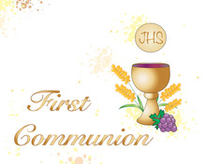
Parents Meeting | Tuesday, January 21st @ 7pm in the lower hall. (parents only)
First Communion Enrollment Mass | Sunday, January 26 @11:30 family mass
First Confession | Wednesday March 12@ 9am in the church  (parents and grade 2 students. Reception in the lower hall to follow)
First Communion Retreat | Saturday, April 26 from 2 – 5 pm (students only) Family Mass to follow (parents and children attend)
First Communion Rehearsal | Tuesday, April 29 @ 7:30 in the church (parents and children)
First Communion | Saturday, May 3 @ 5pm in the church (Students to be dropped off in the gym by (4:30)
*Grade 2 school mass Wednesday, February 5.

